

**Proposed Topic:**

**Analysis of Big-Mart Dataset by using Visualisation in Data Analytics**

Submitted toSubmitted by

Basel Magableh Sai Teja Gouru

10393618

**INDEX**

Objective

Dataset

About Dataset

1. Introduction
2. Proposed System
3. Exploring the Big-Mart Dataset

Conclusion

**Objective:**

The information researchers at Big-Mart have gathered 2013 deals information for 1559 items crosswise over 10 stores in various urban areas. The primary goal is to comprehend whether explicit properties of items or potentially stores assume a noteworthy job as far as expanding or diminishing deals volume. To accomplish this objective, we will construct a prescient model and discover the offers of every item at a specific store. This will help Big-Mart to help their deals by learning advanced item association inside stores.

**Dataset:**

We take information from analyticsvidhya.com, Our information is Big Mart Sales Practice Problem Data, it is open rivalry now and its last date is 31 Dec 2017. We downloaded preparing and test dataset as a csv document.

**About Dataset:**

Everyone needs to realize how to purchase products less expensive or how to promote them with ease. I have been thinking about a similar theme for long time. Here you go the appropriate response. That is Big-Mart. Big-Mart is online one stop commercial centre where you can purchase or sell or publicize your product requiring little to no effort. We will likely make Big-Mart the shopping heaven for purchasers and the advertising answer for vendors.

Numerous individuals state their business is moderate. In any case, we realized a few

organizations are progressing nicely. Why? They imagined that the result of good

association. Among them and the clients. Among them and promoting organizations. They

trust they can furnish their clients with incredible shot of good association. Big-Mart is

helping their sponsors' business develop quick. They additionally give free interview about

business arrangement, stock source and showcasing space. They should go with them.

They are prepared to support customers. They realized they are in the wilderness, focused

market. Be that as it may, they have an expectation. They like the statement "Don't restrict

yourself. Numerous individuals constrain themselves to what they want to do. You can go

the extent that your mind lets you. What you accept, recall, you can achieve". Their

definitive objective is to thrive with their clients. They will do their best for the clients to

appreciate shopping and advertising with ease.

1. **Introduction**

With the fast advancement of worldwide shopping centres and stores chains and the expansion in the quantity of electronic instalment clients, the challenge among the opponent associations is ending up progressively genuine step by step. Every association is attempting to pull in more clients utilizing customized and brief time offers which makes the expectation of future volume of offers of each thing a significant resource in the arranging and stock administration of each association, transport administration, and so on. Due to the shabby accessibility of processing and capacity, it has turned out to be conceivable to utilize advanced AI calculations for this reason. In this paper, we are giving conjecture to the business information of enormous bazaar in various huge shop stores crosswise over different area types which depends on the recorded information of offers volume. As indicated by the qualities of the information, we can utilize the strategy for various direct relapse investigation and arbitrary woodland to estimate the business volume.

1. **Proposed System:**

We propose underneath procedure for taking care of the issue. Crude information gathered at huge store would be pre-prepared for missing information, inconsistencies and exceptions. At that point a calculation would be prepared on this information to make a model. This model would be utilized for determining the last outcomes.

ETL represents Extract, Transform and burden. It is a device which is a mix of three capacities. It is utilized to get information from one database and change it into a reasonable organization. Information preprocessing is an information mining system used to change test crude information into a justifiable configuration. Genuine gathered information might be conflicting, deficient or contains a mistake and subsequently information preprocessing is required. Huge shop's information researchers gathered deals information for the year 2013 of 1559 items crosswise over 10 stores in various urban areas. Additionally, they gave definitions to specific qualities of every item and store. They are as per the following:

1. Item_Identifier - Unique identifier for each product.

2. Item_Weight – Product weight.

3. Item_Fat_Content – Fat content of the product.

4. Item_Visibility – Percentage of total display area in a store allocated to the product.

5. Item_Type – Product category.

6. Item_MRP – List price of the product.

7. Outlet_Identifier - Unique identifier for each store.

8. Outlet_Establishment_Year – Establishment year for each store.

9. Outlet_Size - The size of the store.

10. Outlet_Location_Type - The type of city in which the store is located.

11. Outlet_Type - Whether the store is a grocery store or a supermarket.

12. Item_Outlet_Sales - Sales of the product in each store.

1. **Exploring the Big-Mart Dataset**

Call libraries and read data from file. We used altair library in this program:

import altair as alt

from altair import *

from vega_datasets import data

import pandas as pd

import numpy as np

sales = pd.read_csv('BigMartSales.csv')

sales = sales[:4000]

from google.colab import drive

drive.mount('/content/drive')

sales.count()

Output:

Item_Identifier 4000

Item_Weight 3347

Item_Fat_Content 4000

Item_Visibility 4000

Item_Type 4000

Item_MRP 4000

Outlet_Identifier 4000

Outlet_Establishment_Year 4000

Outlet_Size 2851

Outlet_Location_Type 4000

Outlet_Type 4000

Item_Outlet_Sales 4000

dtype: int64

sales.info()

Output:

<class 'pandas.core.frame.DataFrame'>

RangeIndex: 4000 entries, 0 to 3999

Data columns (total 12 columns):

Item_Identifier 4000 non-null object

Item_Weight 3347 non-null float64

Item_Fat_Content 4000 non-null object

Item_Visibility 4000 non-null float64

Item_Type 4000 non-null object

Item_MRP 4000 non-null float64

Outlet_Identifier 4000 non-null object

Outlet_Establishment_Year 4000 non-null int64

Outlet_Size 2851 non-null object

Outlet_Location_Type 4000 non-null object

Outlet_Type 4000 non-null object

Item_Outlet_Sales 4000 non-null float64

dtypes: float64(4), int64(1), object(7)

memory usage: 375.1+ KB

Here we did a chart on sales of Big-Mart X-axis is Item_Outlet_Sales(binned) and on Y-axis is Count of Records.

**Visualisation 1:**

Chart(sales).mark_bar().encode(

X('Item_Outlet_Sales',bin=True),

Y('count(*):Q'))

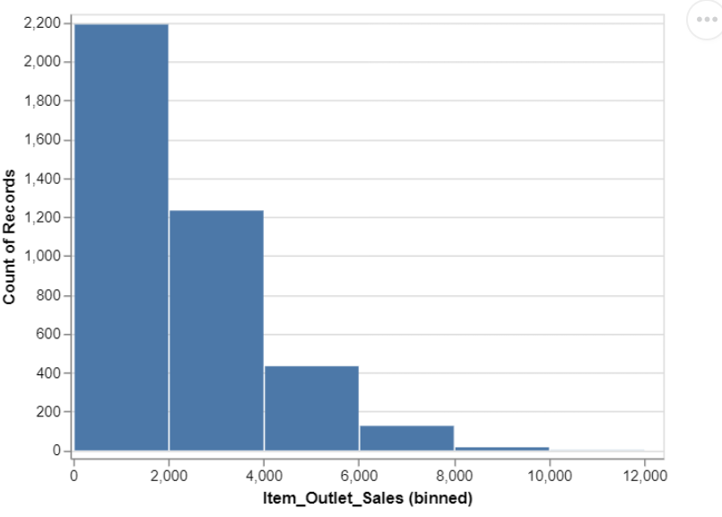

sales.columns

Output:

Index(['Item_Identifier', 'Item_Weight', 'Item_Fat_Content', 'Item_Visibility',

'Item_Type', 'Item_MRP', 'Outlet_Identifier',

'Outlet_Establishment_Year', 'Outlet_Size', 'Outlet_Location_Type',

'Outlet_Type', 'Item_Outlet_Sales'],

dtype='object')

sales.head()

sales.Outlet_Location_Type.unique()

Output:

array(['Tier 1', 'Tier 3', 'Tier 2'], dtype=object)

In this visualisation, we show the alt.chart where we have considered X-axis as Item_ Weight and Y-axis as Item_Visibility.

alt.Chart(sales).mark_point().encode(

x='Item_Weight',

y='Item_Visibility',

color=alt.Color('Item_Fat_Content',scale=alt.Scale(scheme='dark2'))

).configure_axis(

grid=False

).configure_view(

strokeWidth=0

)

**Visualisation 2:**

Output:

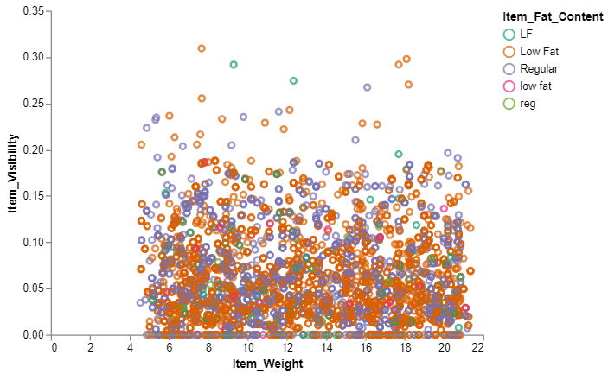

Here in this visualization we considered the sales of the mart by providing the X-axis as Outlet_Establishment_Year and Y-axis as Item_Outlet_Sales by providing the colors of Orange and Steelblue.

alt.Chart(sales).mark_bar().encode(

x='Outlet_Establishment_Year:O',

y="Item_Outlet_Sales:Q",

# The highlight will be set on the result of a conditional statement

color=alt.condition(

alt.datum.Outlet_Establishment_Year == 1985, # If the year is 1810 this test returns True,

alt.value('orange'), # which sets the bar orange.

alt.value('steelblue') # And if it's not true it sets the bar steelblue.

)

).properties(width=600)

**Visualisation 3:**

Output:

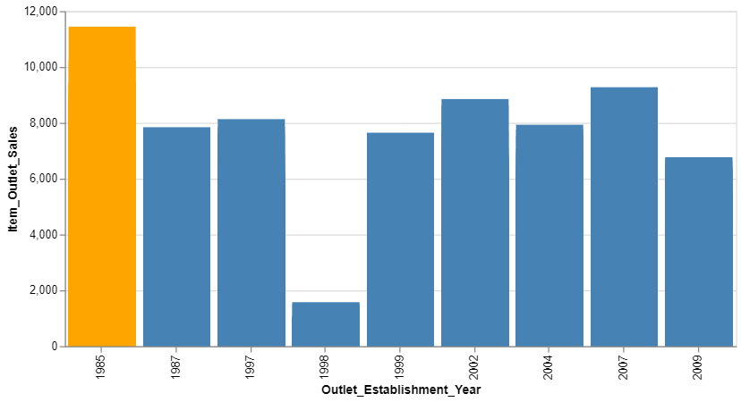

Here we have provided the sales by taking the X-axis as Item_Type and Y-axis as Sum of Item_Output_Sales with the coloring of Outlet_Establishment_Year.

alt.Chart(sales).mark_bar().encode(

x='Item_Type:O',

y='sum(Item_Outlet_Sales):Q',

color='Outlet_Establishment_Year:N',

)

**Visualisation 4:**

Output:

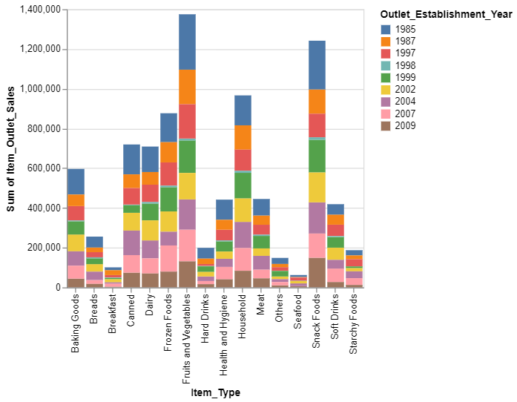

In this visualisation we have considered the X-axis as Outlet_Size and the Y-axis as Sum of Item_Outlet_Sales. Here we have chosen the color as Outlet_Location_Type.

alt.Chart(sales).mark_bar().encode(

x='Outlet_Size:O',

y='sum(Item_Outlet_Sales):Q',

color='Outlet_Location_Type:N',

column= 'Outlet_Type:N'

)

**Visualisation 5:**

Output:

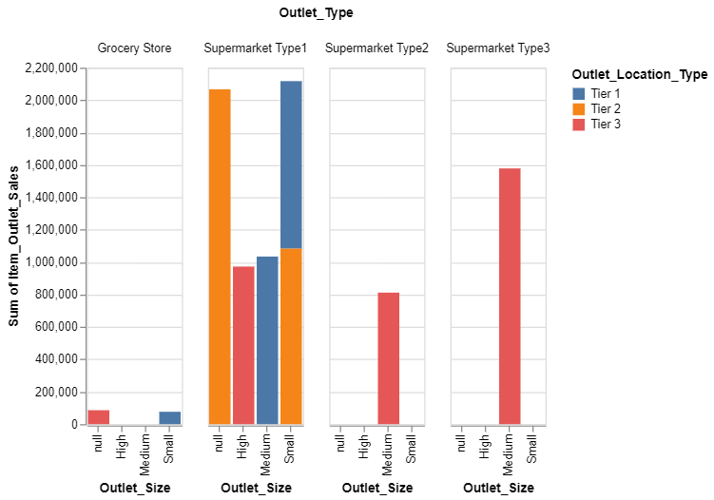

**Visualisation 6:**

brush = alt.selection(type='interval')

points = alt.Chart(sales).mark_point().encode(

x='Item_MRP:Q',

y='Item_Outlet_Sales:Q',

color=alt.condition(brush, 'Outlet_Location_Type:N', alt.value('lightgray'))

).add_selection(

brush

)

bars = alt.Chart(sales).mark_bar().encode(

y='Outlet_Location_Type:N',

color='Outlet_Location_Type:N',

x='count(Outlet_Location_Type):Q'

).transform_filter(

brush

)

points & bars

Output:

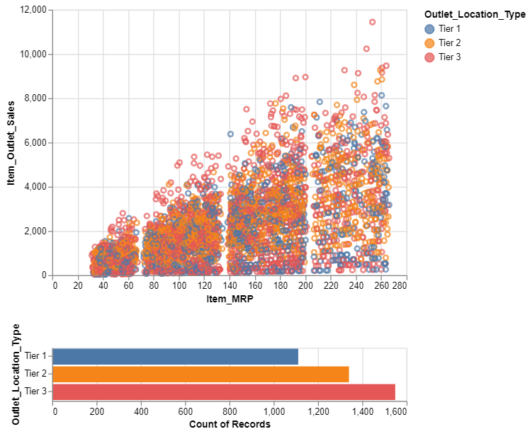

sales.Item_Type.unique()

array(['Dairy', 'Soft Drinks', 'Meat', 'Fruits and Vegetables',

'Household', 'Baking Goods', 'Snack Foods', 'Frozen Foods',

'Breakfast', 'Health and Hygiene', 'Hard Drinks', 'Canned',

'Breads', 'Starchy Foods', 'Others', 'Seafood'], dtype=object)

Code:

**Visualisation 7:**

scale = alt.Scale(domain=['Supermarket Type1', 'Supermarket Type2', 'Supermarket Type3', 'Grocery Store'],

range=['#e7ba52', '#c7c7c7', '#aec7e8', '#1f77b4', '#9467bd'])

alt.Chart(sales).mark_bar().encode(

x='count()',

y='Outlet_Type:N',

color=alt.Color('Outlet_Type:N', scale=scale),

)

Output:

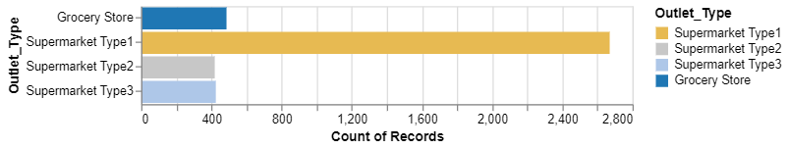

**Visualisation 8:**

scale1 = alt.Scale(domain=['Dairy', 'Soft Drinks', 'Meat', 'Fruits and Vegetables',

'Household', 'Baking Goods', 'Snack Foods', 'Frozen Foods',

'Breakfast', 'Health and Hygiene', 'Hard Drinks', 'Canned',

'Breads', 'Starchy Foods', 'Others', 'Seafood'],

range=['#e7ba52', '#c7c7c7', '#aec7e8', '#1f77b4', '#9467bd','brown'])

alt.Chart(sales).mark_bar().encode(

x='count()',

y='Item_Type:N',

color=alt.Color('Item_Type:N', scale=scale1),

)

Output:

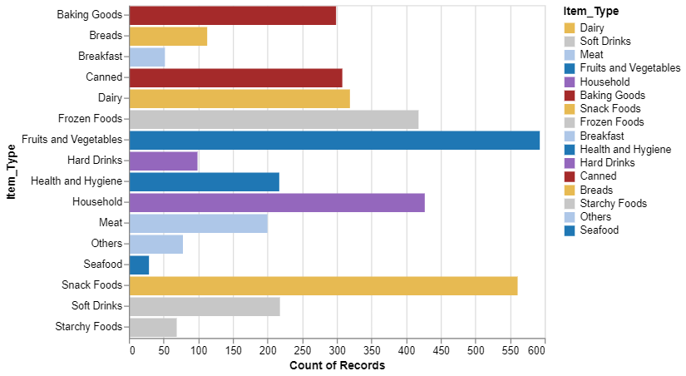

sales.columns

Index(['Item_Identifier', 'Item_Weight', 'Item_Fat_Content', 'Item_Visibility',

'Item_Type', 'Item_MRP', 'Outlet_Identifier',

'Outlet_Establishment_Year', 'Outlet_Size', 'Outlet_Location_Type',

'Outlet_Type', 'Item_Outlet_Sales'],

dtype='object')

**Visualisation 9:**

alt.Chart(sales).mark_bar().encode(

x='Item_Visibility',

y='Outlet_Size',

color='Outlet_Type'

).configure_mark(

opacity=0.2,

)

Output:

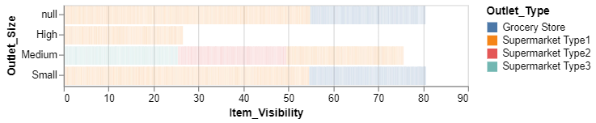

**Visualisation 10:**

alt.Chart(sales).mark_bar().encode(

x='Outlet_Establishment_Year:N',

y='Item_Outlet_Sales:Q',

opacity=alt.value(1),

color=alt.Color('Outlet_Location_Type',scale=alt.Scale(scheme='dark2'))

)

Output:

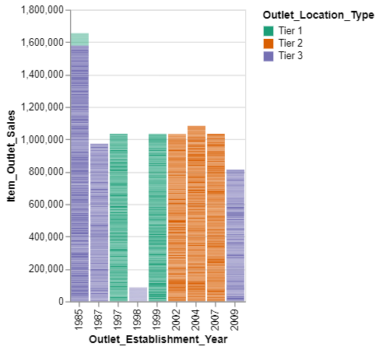

**Visualisation 11:**

alt.Chart(sales).mark_bar().encode(

x='Item_Type:N',

y='Item_MRP:Q',

color='Outlet_Location_Type'

)

Output:

we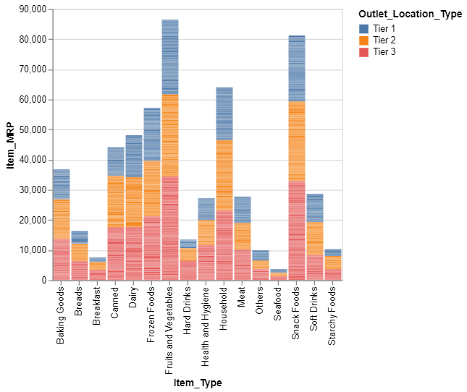

**Conclusion**

In this we say that we have used the Altair library for visualising the attributes of the dataset.